

Technical Test

Full-Stack Developer

Name:​Jorge Mario Gamarra Ponce

The goal of this test is to learn more about who you are as a developer and your skills. There is no trick or puzzle. We look for people that can write robust and clean code, know the best practices and can work efficiently with their colleagues. We do not expect you to be an expert in all areas. We are looking for one strong area as well as a minimal understanding of other areas. Answer the questions with as many details as you can and if anything is unknown to you or unclear, do not hesitate to mention it in the answer.

Send your answers by email to btremblay@ueat.io. Also include the code you wrote in a ZIP file with instructions on how to run it.

Thank you and good luck!

General

- What languages, tools and frameworks are you an expert in? What have you learned recently?
I am an expert in:
Languages: C#, SQL, ORACLE, jquery, javascript,
Tools: Visual Studio 2010-2019, Sql Server 2005-2019, Oracle 12-18, Postman, Soap-ui.
Framework: .Net, Bootstrap.
I am not an expert, but I use angular, vue, react, Docker, visual-code, Azure
I learned recently firebase, GCP, Linux, graphql

- You have a deadline you must absolutely meet for a customer and you know you will not be able to meet it. How would you handle the situation to make sure the customer is satisfied?
My objective was to agreed with the customer. There are no exceptions for not presenting it. But If I encounter some problem to accomplish my deal. I could coordinate with the customer to reduce the scope. For example, I could sacrifice the design but not the functionality. In this way the customer will can appreciate the functionality that he needs anyway.
However, if I am very close to finishing. I can coordinate some time additional to finish my project
Overall, I consider extra time to critical activities to prevent this situation because I prefer presenting complete develops.

- What are the top 3 qualities you are looking for in your developer teammates?

- Good practices: They must have good knowledge of POO, SOLID principles and clean -code understanding.
- Responsibility: Focus and effort on the task.
- Communicative: They must have confident with the team and they must have open to help anybody.

- What are the top 3 code smells (bad practices) you want to avoid at all cost in your code?
- Clean-code practices:
Expose sensible data in files,
pieces of code very long, it is difficult to read and maintain.
wrong parameter transport, majority all parameters will be passed by an object
- Descriptive names:
If you use appropriate names you can understand the content of the piece of code so probably you cannot need to comment.
- Ability to adapt:
Coordinate with new teams,
Share opinions.

Frontend

For the following section, you can use React.js, Angular.js or Vue.js. Use what you are the most comfortable with.

- Write a login form component. The user should be asked for an email address and a password. If it matches, the app should display a welcome message. If it does not match, an error should be shown. You can split the component into multiple ones. The password can be hard-coded or use the API from the backend section. You can use a UI library, but make sure to show the usage of CSS flexbox or grid.

- Write tests for the previous login form component with 100% test coverage.

- How would you protect that login form from bots or hackers?

I can implement a captcha.
I can use some libraries in angular
I can restrict the number of attempts
I can separate Login and password, similar to a login from gmail

- Describe the most common security issues a frontend can have and how to make sure to protect against them.
Protect the endpoints or resources of the application,
Do not protect the access to routes
Do not mask the parameter of the query string, you must use an aleatory id
Abuse of the localstorage
Do not clean the localstorage

- What is a Progressive Web App (PWA) and when should you use it?

It is a sort of improvements in a web to make similar behavior in a mobile or desktop.
This application uses the same basic resources in the web such as html, js , css , end-point to show the user a similar experience such a mobile or desktop.
The main difference is that they do not use appropriacy the software of the mobile, they are not native applications.

Backend

For the following section, you can use C#, Java, Node.js or Go. Again, use what you are the most comfortable with.

- Write a login API endpoint. You must be able to receive the email address and password and verify if it matches with a password saved in a database. Make sure to split the responsibilities of each class or files like a large application would do.

- Write tests for the previous login API endpoint with 100% test coverage.

- How can you make sure your user passwords are safe?

I can use jwt and involve the password in a token
I can use a hash and use a mechanism to decode and code password according to a specific hash.

- Describe the repository pattern and when it is useful to use it.

Each repository keeps a logic about specific concept, can be an operation in a database, operations in an entity
They keep a single responsibility talking about logic.
In a developer point of view, It is useful to adapt developers to code in the same way.
They must follow the definitions with a specific parameter.
This pattern allows the application to be less coupled or flexible to future changes.
Reduce the impact if I need to do a change in all functionalities of a repository

- What are the pros and cons of using a microservice architecture vs monolithic architecture?

Monolithic:
- Pros:
Easily you can maintain because you Will encounter all in one space.
You do not need to work in integration,
High coupling
You do not need to configure different servers
- Cons:
It is difficult to work between teams because you Will need to coordinate for changes.
If you have problems with the server, you Will have to re deploy whole application
Microservice architecture:
- Pros:
Less coupling
Teams can work in a distributive way. they only work in a part of application
Easily to maintain
Distributive application
Scalability,
You have alternatives if you want to recover the application in realtime (example: containers, orchestration)
You must work in integration between applications
- Cons
You need to configure different servers
If you want to recover an application, you will have to recover each application

- Describe an application architecture you designed or used you are proud of.
Location of the Problem: well-known bank in Peru
Problems:
Multiple agencies around Peru (20-30), the transfer of data was not online.
Users use different devices at any time.
Internet connectivity unstable
Long data information sometimes lost

I had the chance to build whole modules of logistics, sales, production that helps to improve operations of users.
I really enjoyed with logistics operations in different companies (maritime, production, sales)
In recent years I like to work with webservices and apis , I can apply appis in different ways using websocket or http.
I believe my work at the bank was the most important for me because I can understand the power of the communications.
I have the chance to bring to the bank a new technology and change a monolithic application that they used with database in AS400 and web pages in different platform some of them in java others in .net or php.
I have only one application server in windows and linux , and a very secure database in AS400 .
I had to convert the application in an api-rest full and one web page for the front using asp.net with jquery , html5 , css3 because I had a slow communication between agencies. At this time, they were using different browser.
They web application was using mvc and tiers, for separate busines, domain, and UI
The api rest was using mvc and tiers too, but I used some additional objects for mapping objects from the front.
I had a tier for database, because I used AS400 and sql server, and we want to change faster new connections and stores because the version of the platform changed a lot of times.
In the database I used store procedures, jobs and work with team in AS400 they help us with the RPG programs, and I called this rpg programs for the api rest full.

Infrastructure

For the following section, you can use AWS, Azure or Google Cloud.

Again, use what you are the most comfortable with.

- Our billing department needs a system to help them bill our customers each month. The application must generate invoices at the beginning of each month based on it’s usage of our products. It can be running with the language and database of your choice. How would you design the infrastructure to make the system robust and reliable? Describe the components and how they would interact together. You can make up any assumptions on how the application works and focus on the infrastructure part.

Assumptions:
They have all his information at cloud GCP.
They can register products of each customer
They do not send the invoice; the invoice is available only for download
The language can be react, vue o angular
Actors:
Billing Department: Previously they register information (products) of each customer
Customer: User that needs his invoice
GCP: Through an event they generate each invoice for each customer.
Resources:
Billing System: Software Application can be mobile or web, apparently has conditions to be a PWA.
Database: Cloud Firestore (database no relational)
Component inside GCP: Cloud Function like a job in sql (You can schedule and then it will trigger an action)
Containers – Kubernetes: Place where the programs to generate invoices, print will be active.
Reason for this choice:
Advantages:
I choose only those code languages because they provide advantages in security rather than a simple html, css, javascript
All these code languages work perfectly with firebase. They provide information in realtime and its very faster.
Container, this mechanism is much better if I need to scale my application.
If I must receive more users If I have technical problems or the applications are down.
Disadvantages:
The cost could be a problem, because GCP will increase cost if we do not use appropriacy our resources.
The technical staff must have trained.
Some of these components are expensive but all components are efficient
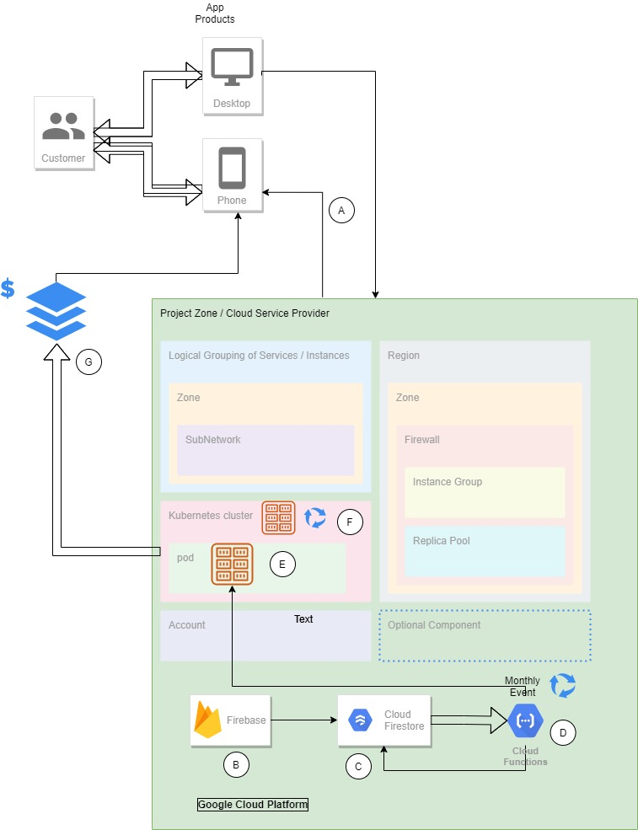
A.-The user interact with his application If they need to register products of the customers, the application was deployed in a service on container.
B.-The application keep communication with firebase for authentication, rules.
C.-Firebase works with Cloud Firestore for store or recover information.
D.-Cloud Function is an event that triggered at beginning of each month, this function will invocate another container with the program of the invoice generator.
E.-The program invoice generator will create invoices for each customer. At this point you can decide if send invoice by email or save the invoice in the repository of cloud, for cost maybe will be better send by email.
F.-This graphic represent how the Kubernetes works, if something occurs Kubernetes will control each container and the capacity of our system, if we need more capacity, they will create more containers temporary or until the work will be done.
G.-This represents the moment when the user asks for his invoice and he download it
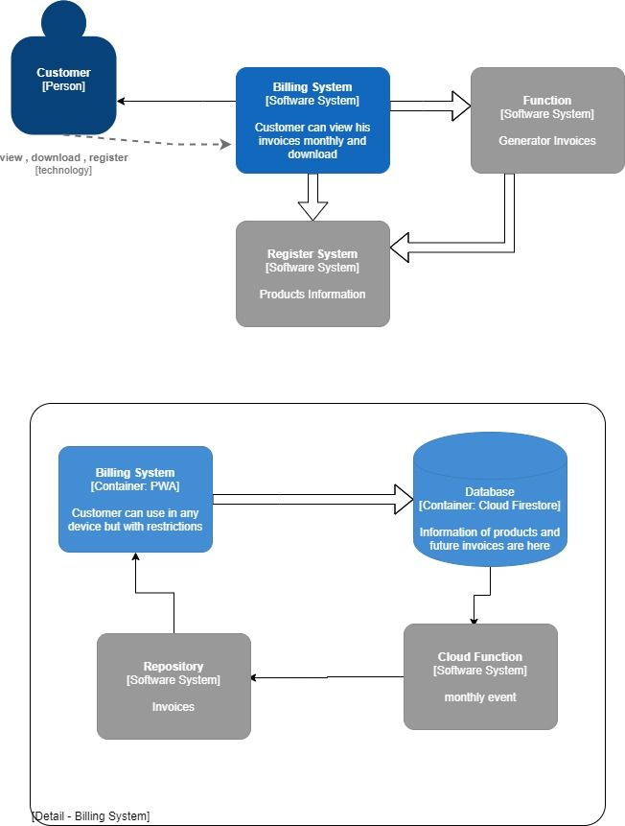

The first picture shows the interact between the customer and the system.
The second is the detail of the Billing System and tells how It interact internally with each component in GCP.

